**What is an API?**

**Definitions, Examples, and Resources to Get Started with** [**What Does API Stand For?**](https://stoplight.io/what-is-an-api#what-does-api-stand-for)

API stands for “application programming interface.”

More simply, it is a collection of definitions, instructions, and protocols for building and connecting software. An API is the connection between two programs that exposes the select business or operational value of one to the other.

* APIs establish a connection between systems and enables data access
* Allows monitoring of users and their activity
* Well-designed APIs Increase security
* Hides back-end complexity from developers

**[Why Do APIs Matter?](https://stoplight.io/what-is-an-api" \l "why-do-apis-matter)**

Application programming interfaces (APIs) shield developers from the complexities of the systems they’re trying to work with. They let your product or service communicate with other products and services without having to know or access the backend, simplifying the process and saving both time and money on the development side.

When your organization is looking to create new tools and products or update existing ones, using APIs can provide flexibility, simplify the design steps, offer easier administration, and lower infrastructure costs.

"Because APIs simplify how developers integrate new application components into an existing architecture, they help business and IT teams collaborate. Business needs often > change quickly in response to ever shifting digital markets, where new competitors can change a whole industry with a new app. In order to stay competitive, it's important > to support the rapid development and deployment of innovative services."- [Source - Red Hat](https://www.redhat.com/en/topics/api/what-are-application-programming-interfaces)

APIs are a simpler method of connecting your infrastructure through the Internet and sharing your data with customers, partners, and even internal users. Public APIs in particular create huge business value because they expand how you connect and monetize your data with other programs.

**[The API is a Messenger](https://stoplight.io/what-is-an-api" \l "the-api-is-a-messenger)**

We've all heard the analogy of APIs being compared to a restaurant, but I'd like to try to spin up something a little bit different.

I think APIs are like delivering a package.

As we discussed above, APIs have standards that represent an agreement between two parties. If the first party sends a remote request that is structured in a specific way, the API contract determines how the second party’s software responds.

Similarly, you have to follow a set series of instructions to correctly address a package for delivery and pay the appropriate postage. After following those instructions you have a specific set of expected outcomes.

In this case, you expect that the package will be delivered.

The API comes into play in that whole middle section.There are many functions and operations that happen from the moment the package leaves your hand and goes through the shipping service to reach the expected outcome of delivery.

These middle functions are abstracted; you don't need to know all the steps and processes of the postal service or the backend work that goes into delivering your package. You just need to be safe in knowing that you follow the required steps in order to make it happen. You expect the Postal Service to do the rest

The same can be said for APIs. Following the protocols of the API, developers don’t need to know the back-end systems and processes in order to reap the benefits of the value of the API. Everything works as expected, and the transaction benefits both parties.

**[APIs Serve Your Customers](https://stoplight.io/what-is-an-api" \l "apis-serve-your-customers)**

Companies are now delivering APIs as products. This is more than a trend; it’s now a way of doing business.You have to think of your end user as a customer, even if they’re internal users within your own organization.

Your API should be:

* Easy to use and understand to increase adoption
* Predictable and secure
* Open to feedback

Because you should take a customer-centric approach to creating APIs, you should consider learning about [API Design](https://stoplight.io/api-design-guide). Well-designed APIs consider your end users, your desired outcomes, and improve the costs and time-to-market

**[Type of APIs](https://stoplight.io/what-is-an-api" \l "type-of-apis)**

Just like applications don’t just come in one flavor and don’t just have one purpose, APIs also come in a variety of uses and purposes.

* **Private APIs** are used inside an organization to integrate internal systems and apps used by employees. The goal of these APIs is to improve the internal operations and user experience of internal teams, and to reduce costs of building their own systems from the ground up. Even if it might appear open to the public, a Private API interface remains available only for those within the organization.
* **Partner APIs** are created to provide additional revenue streams and are shared resources between business partnerships. A business partner makes an agreement with an API creator that allows for benefits between the two parties including data and customer sharing.
* **Public APIs** are available for third-party developers to use when creating their own projects and products. These types of APIs don’t require a close relationship between the end user and the publisher, though a great developer experience leads to higher adoption and better user satisfaction. Public APIs can increase revenue opportunities by helping to reach larger audiences and build a traffic pipeline between systems. They can and also support a large variety of causes and of business initiatives including open/free use or commercial.

**[Examples of APIs](https://stoplight.io/what-is-an-api" \l "examples-of-apis)**

Now let's look at a real-world example of APIs in the wild. When you create a new account on an app, you often get the option to sign-up using your Facebook or Google account. Have you ever wondered how that works?

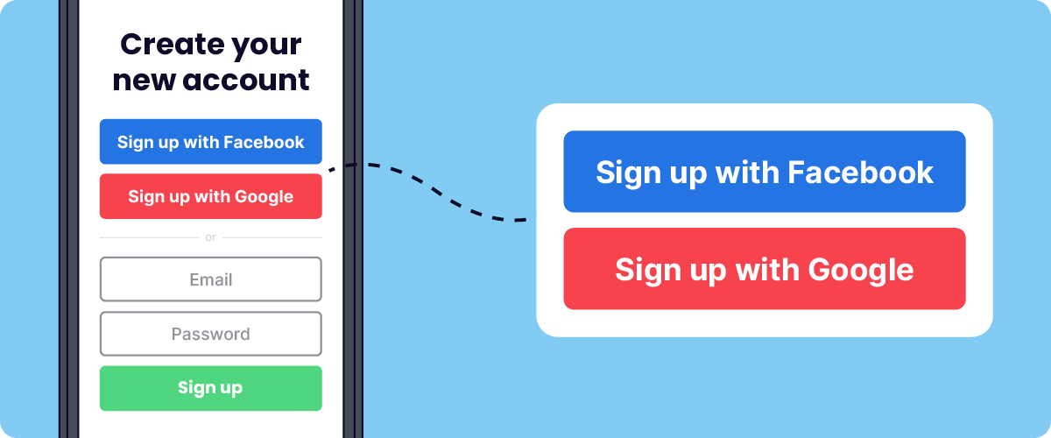

Apps like Facebook and Google already have your data. Instead of performing the tedious, costly, and risky task of capturing every user's information, the app accesses the Google and Facebook databases through an API to verify your login credentials.

The benefits of this API for the app is less risk, easier adoption, and faster time to convert you into a user. The benefits for Facebook and Google is increased reach and more information about how and what you’re accessing that they can provide to advertisers.

**[APIs for Access Control](https://stoplight.io/what-is-an-api" \l "apis-for-access-control)**

APIs are also used to control access to functions and resources that other applications do not have permission to use. That’s why APIs play a large role in software security.

"If you’ve ever visited a website and seen a message in your browser that the website is asking to see your precise location, that website is attempting to use the geolocation API in your web browser. Web browsers expose APIs like this to make it easy for web developers to access your location—they can just ask “where are you?” and the browser does the hard work of accessing GPS or nearby Wi-Fi networks to find your physical location." - [Source](https://swiftheadline.com/what-is-an-api-and-how-do-developers-use-them/)

Browsers expose this info through an API because of the ability to strictly control access. When a website wants to access your physical location, they have to go through the location API; this gives both the API and you, the user, the option to allow or deny their access request.

You’ll often hear developers talking about the functionalities of different APIs, but there’s another important, less discussed aspect: the documentation. Without the knowledge in it, an API might as well be a bunch of hieroglyphs.

**[APIs are Everywhere](https://stoplight.io/what-is-an-api" \l "apis-are-everywhere)**

As you’ve probably learned by now, APIs are one of the world’s best tools for global connection and growth. Communication between applications is essential to achieve business and organizational goals. Learn more about the benefits and uses of APIs by subscribing to the Stoplight Blog.

**[More API Resources to Get Started](https://stoplight.io/what-is-an-api" \l "more-api-resources-to-get-started)**

We’re here to help. Feel free to bookmark this page as a resource in your continuing quest for more API education. Reach out to Stoplight on [social media](https://stoplight.io/press#social/), or join the Stoplight Discord Community to get involved!

* [APIs for Beginners: Free Full Course from freeCodeCamp.org](https://www.freecodecamp.org/news/apis-for-beginners-full-course/)
* [APIs for Dummies](https://apimetrics.io/api-knowledge-base/apis-for-dummies/)
* [API Examples in Ecommerce](https://www.bigcommerce.com/blog/what-is-an-api/)
* [Learn About API Design](https://stoplight.io/api-design-guide)
* [9 Best APIs for Beginners from RapidAPI](https://rapidapi.com/collection/best-apis-for-beginners)

**[Common API Terms](https://stoplight.io/what-is-an-api" \l "common-api-terms)**

* **What is an API Specification?**

An API specification is a document or set of standards that describes how to build or use such a connection or interface. A system that meets these standards can implement or expose an API. The term API may refer either to the specification itself or to the resulting implementation. Learn how to use Stoplight to create an OpenAPI specification [in this tutorial](https://idratherbewriting.com/learnapidoc/pubapis_openapis_quickstart_stoplight.html).

* **What is an API endpoint?**

An API endpoint is a point at which an API connects with a software program. More simply, an endpoint is at the end of a communication channel. An endpoint is the location from which APIs access the resources they need to carry out their function and can include the URL of a server or service. Learn about the function of endpoints in API design in this [Stoplight documentation](https://meta.stoplight.io/docs/platform/ZG9jOjIwMTI3OA-start-a-new-api-design).

* **What is API Documentation?**

API documentation, or API description docss, are the collection of references, tutorials, and examples that help developers use your API. It is the primary resource for explaining what your API can do and how to get started. It also serves as a place for developers to answer questions about syntax or functionality. [Learn more about API Documentation in this guide.](https://stoplight.io/api-documentation-guide)

* **What is a REST/SOAP API?**

APIs come in many forms. API designers can choose from a range of protocols and standards, depending on the purpose of the API that they’re creating..Learn all about the types of APIs including RESTful and SOAP and their functions in this comprehensive [article](https://stoplight.io/api-types).